FOCP ASSIGNMENT 1

MODULE 5
Ques 2
power of 3
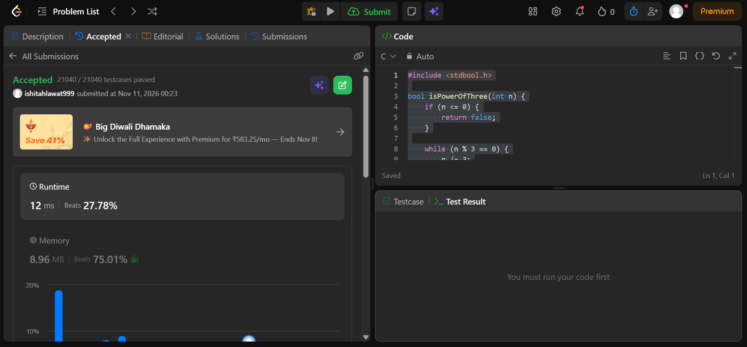

#include <stdbool.h>

bool isPowerOfThree(int n) {
if (n <= 0) {
return false;
}

while (n % 3 == 0) {
n /= 3;
}

return n == 1;
}

